|  |  |  |  |  |  |
| --- | --- | --- | --- | --- | --- |
| **Module No:** | 8 | **IU No:** | 3 | **Exercise No.** | 2 |

|  |  |
| --- | --- |
| **Lab Assessment Statement** | **Assignment 2 - Build React JS Frontend Application**  **Referring to Assignment-1's Project Scenario,**  The scope of this assignment is to develop a frontend for ‘XYZ Cars Pte Ltd’ as a React developer to develop a Used Car Sales portal.  These are the steps provided to build an API.   1. Install Node JS. 2. Create React Application using **npx creact-react-app [project name]** command. 3. Run Application using **npm start** command. 4. Create Service to fetch the data from API. 5. Create methods to make HTTP REST call via Axios. 6. Create the required components to display the data coming from services. 7. Implement React Router to configure routing links.   **Provide the source code of developed application.**  **Provide screen capture of final result pages for API testing.** |
| **Technical Environment** | - REST API, React JS |
| **Guidelines** | - |
| **Duration** | 120 mins |

1. Install Node JS.
   1. Go to nodejs.org and download the LTS

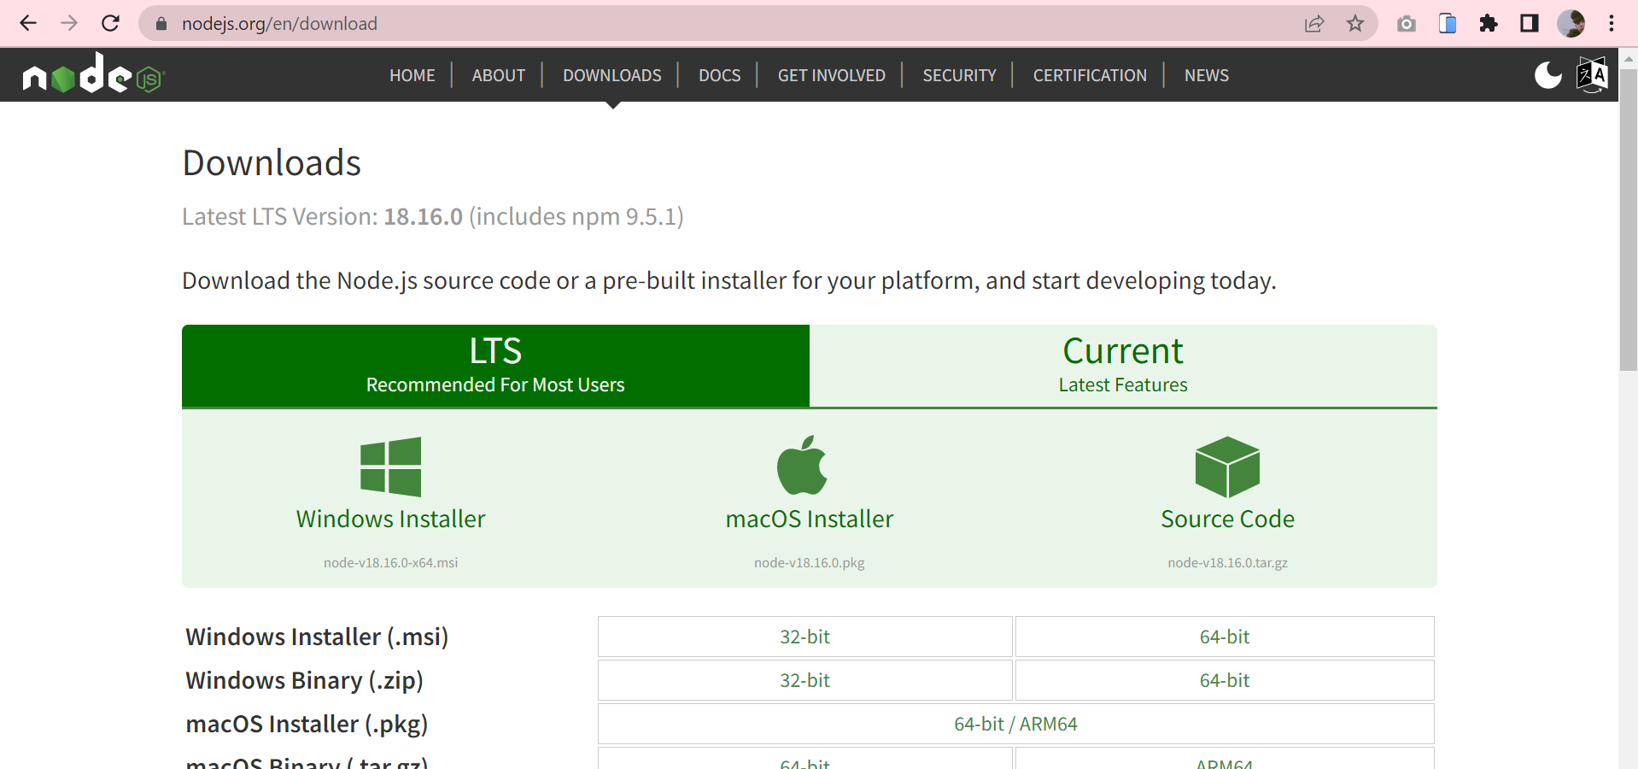

* 1. After that click and click next until finish  
     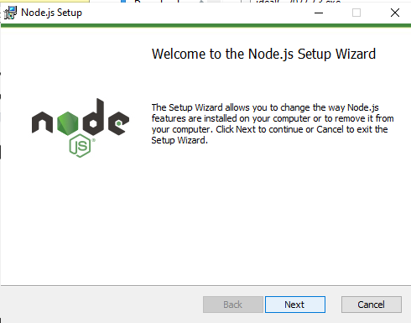
  2. After finish, open the command and enter node -v   
     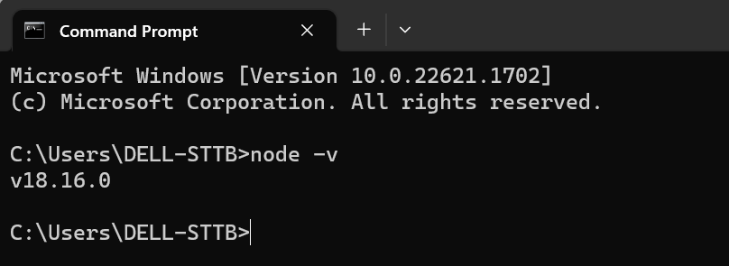

1. Create React Application using **npx creact-react-app [****assignment2]** command.
   1. Open terminal in vs code and write npx creact-react-app assignment2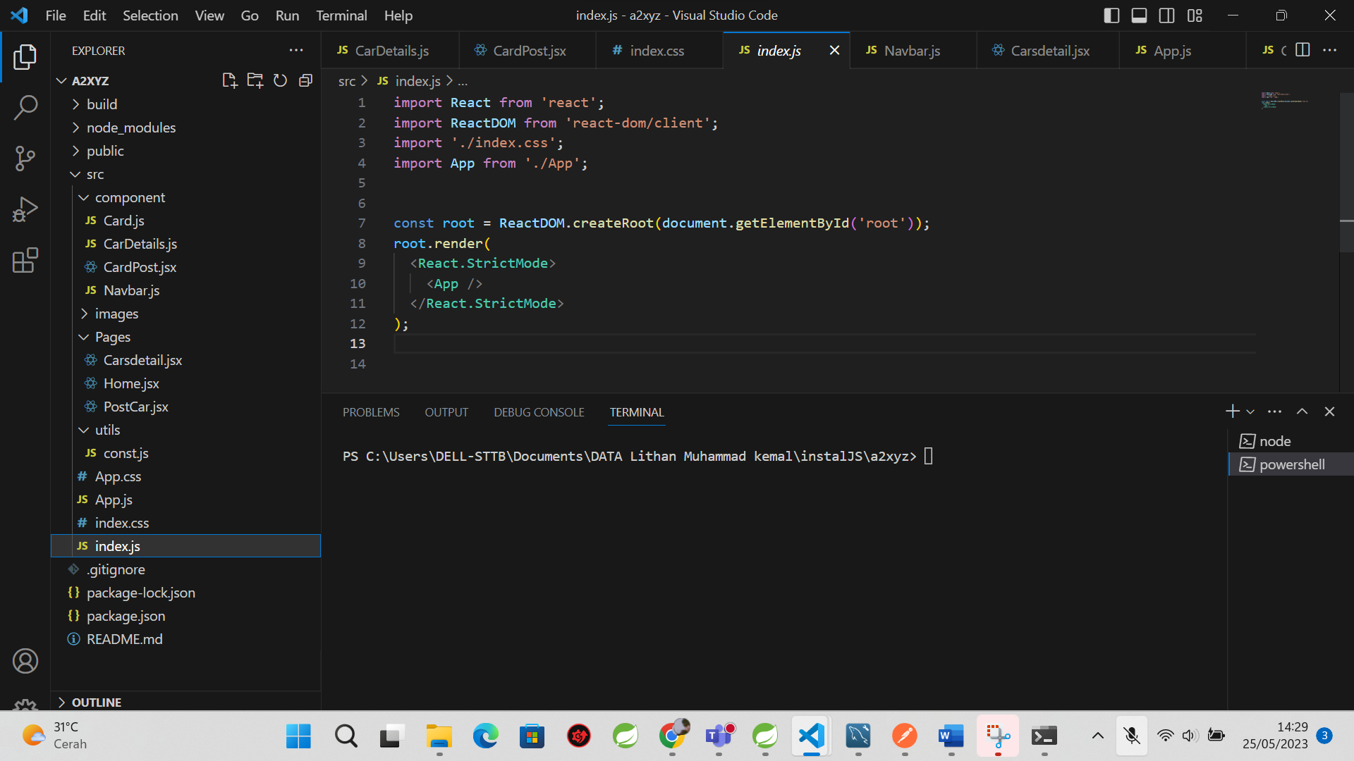
   2. In terminal write npm install react-router-dom  
      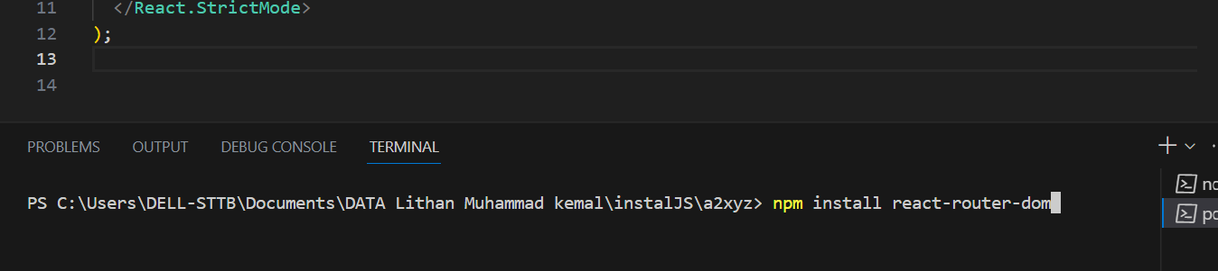
   3. In terminal write npm install axios  
      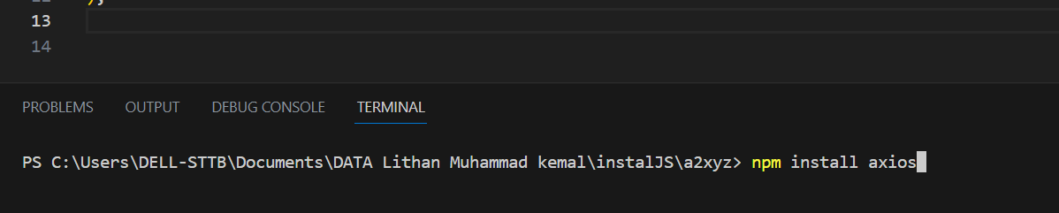
2. Run Application using **npm start** command.

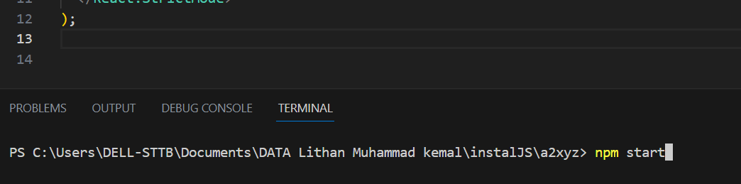

1. Create Service to fetch the data from API.
   1. there is my compenents  
      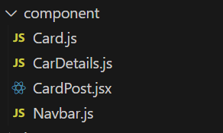
2. Create methods to make HTTP REST call via Axios.
   1. Card.js  
      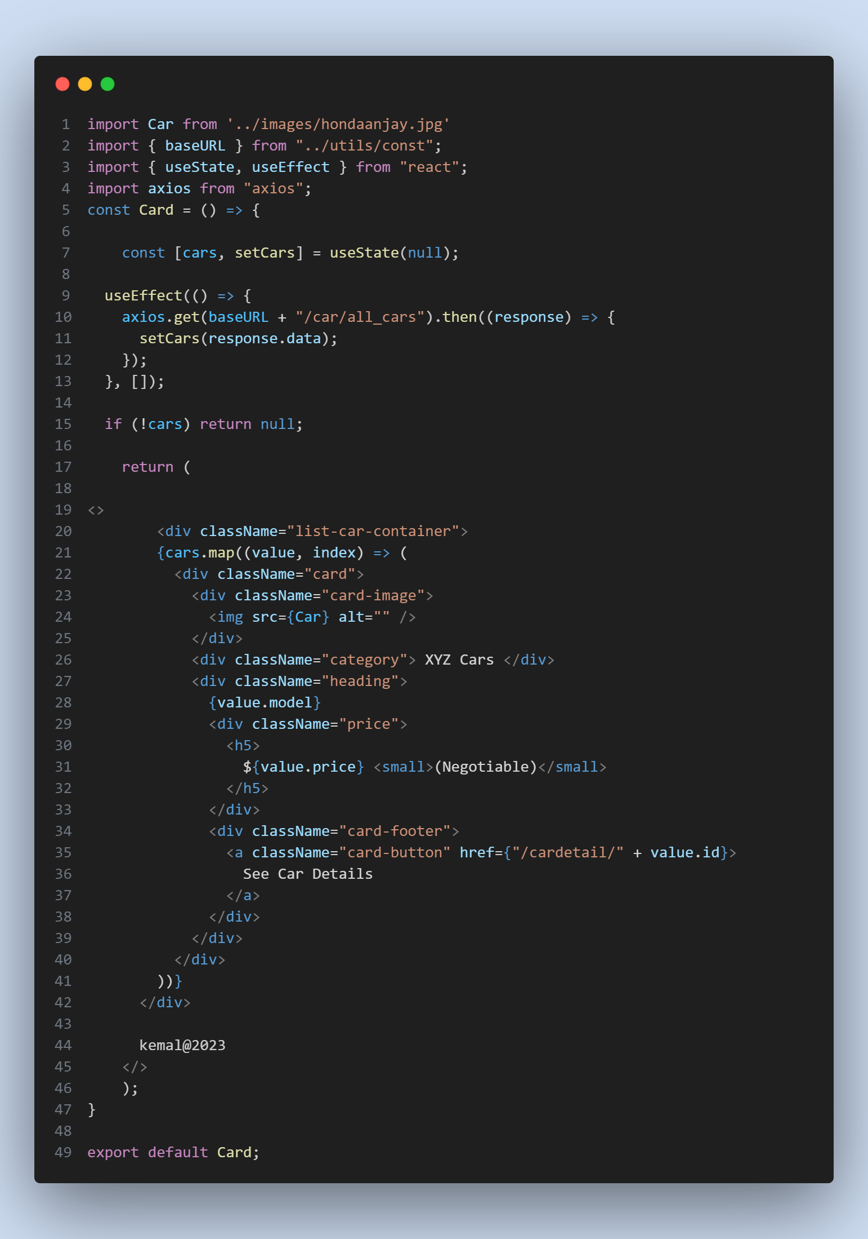
   2. CarPost.js  
      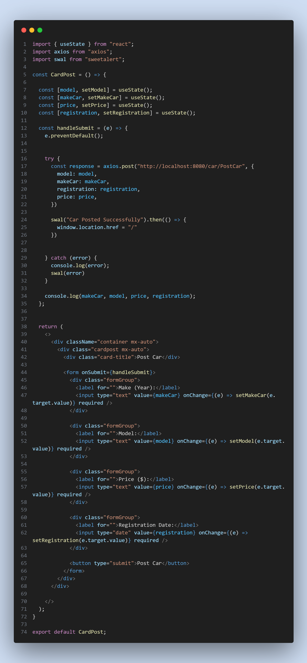
   3. CarDetails.jsx  
      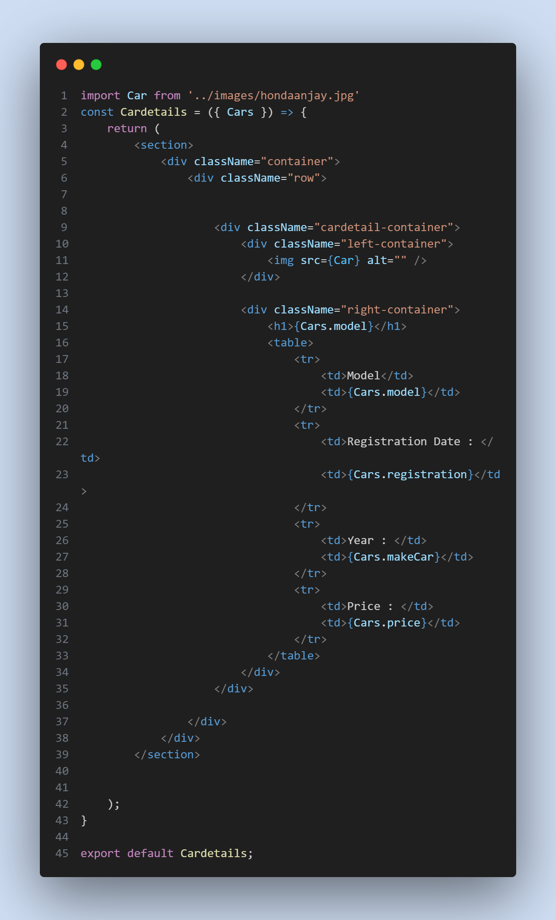
3. Create the required components to display the data coming from services.
   1. Card.js   
      
   2. CarPost.js  
      
   3. CardDetails.js  
      
   4. Navbar.js  
      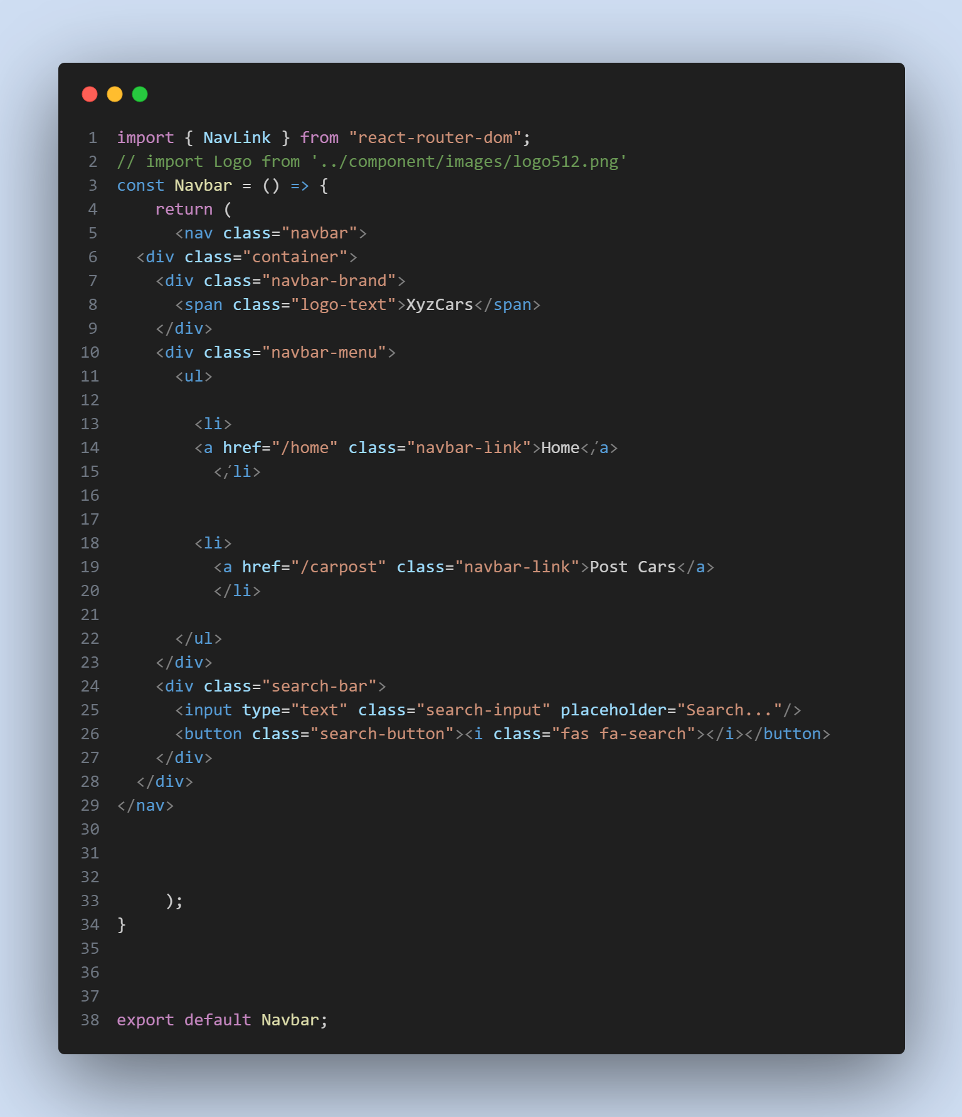
4. Implement React Router to configure routing links.
   1. Router Code in App.js  
      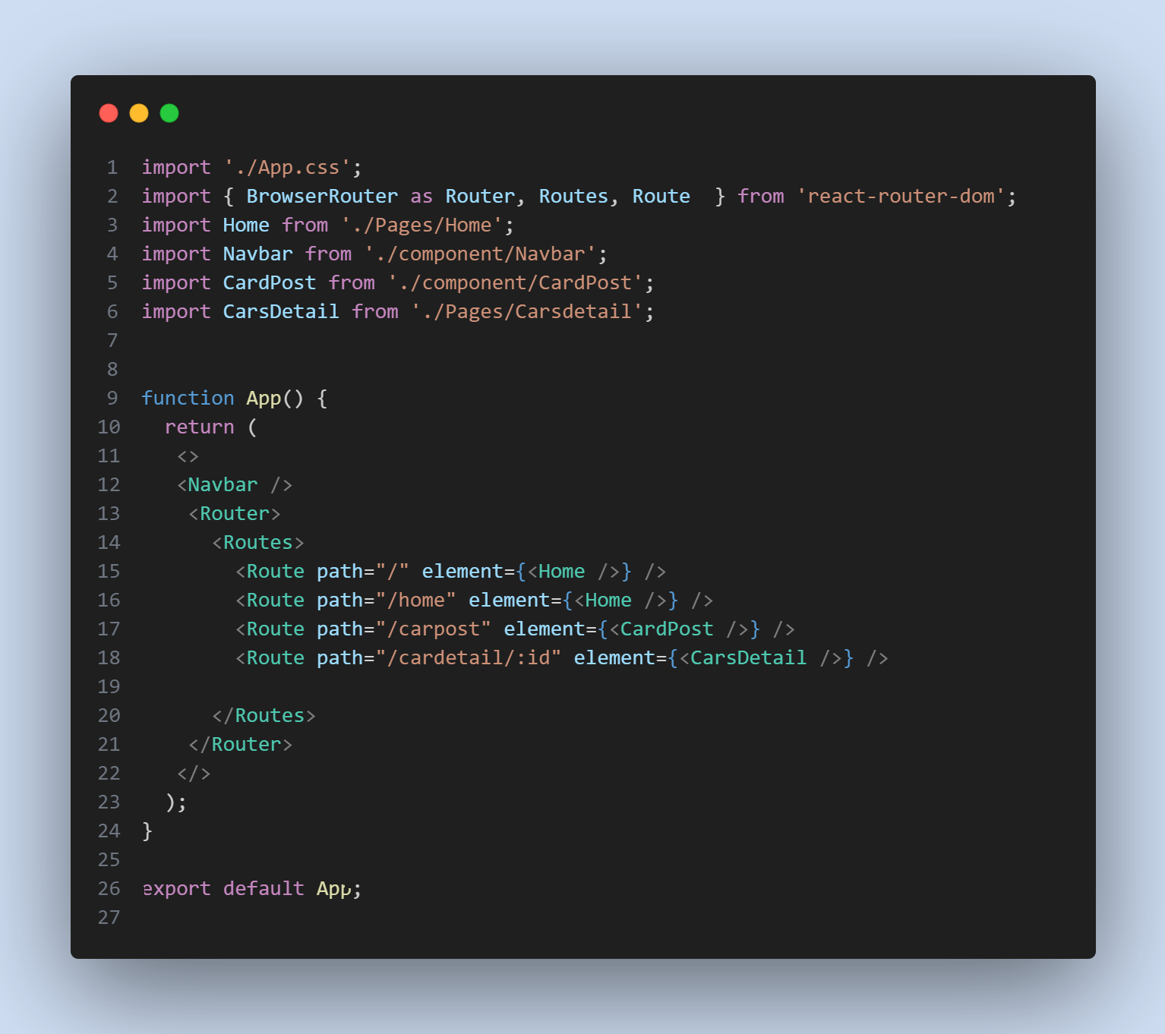
5. Screen Capture of Final Project
   1. Home with a view Car (GET Method)  
      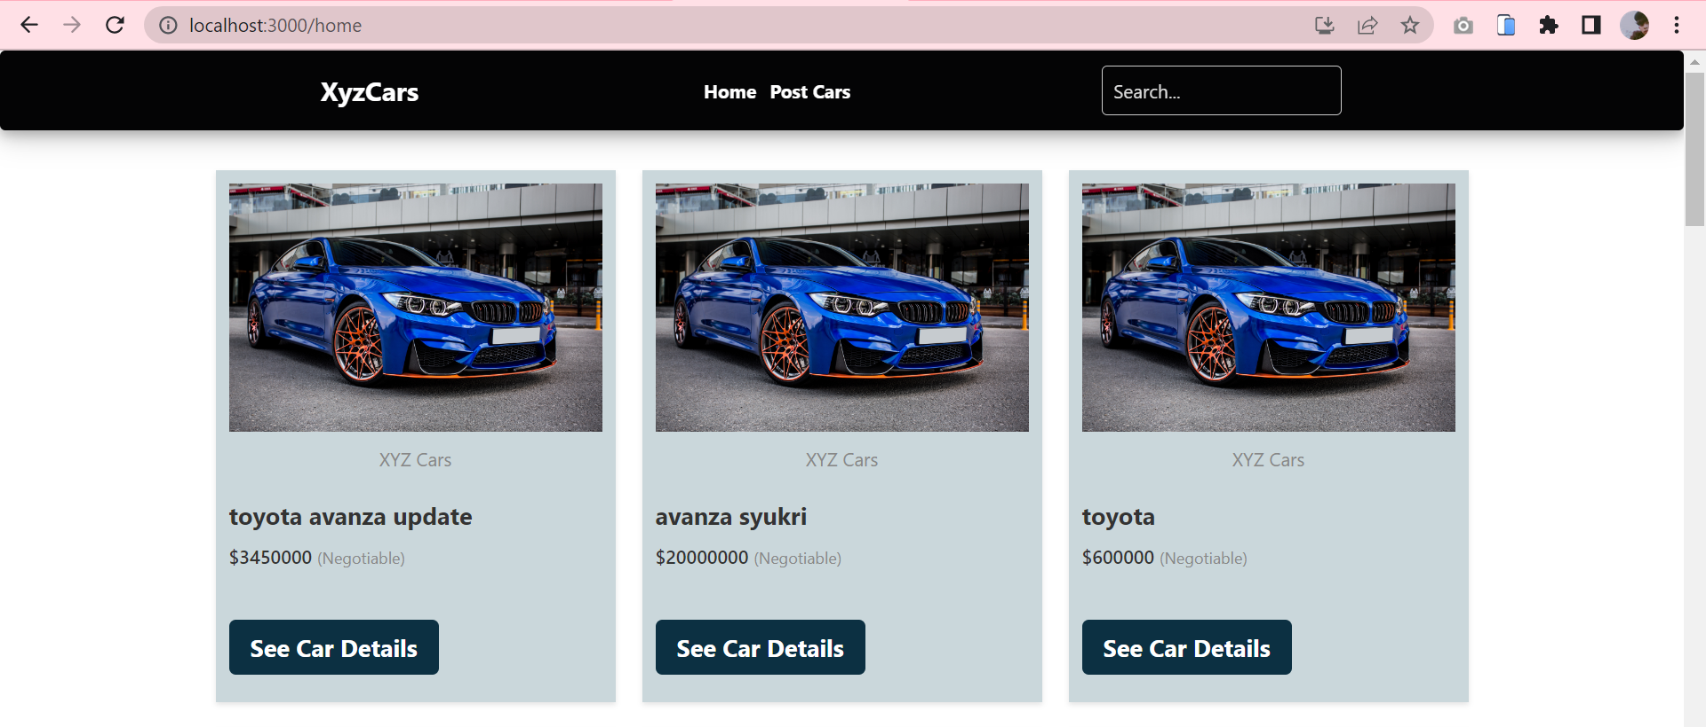
   2. Post Car (POST Method)  
      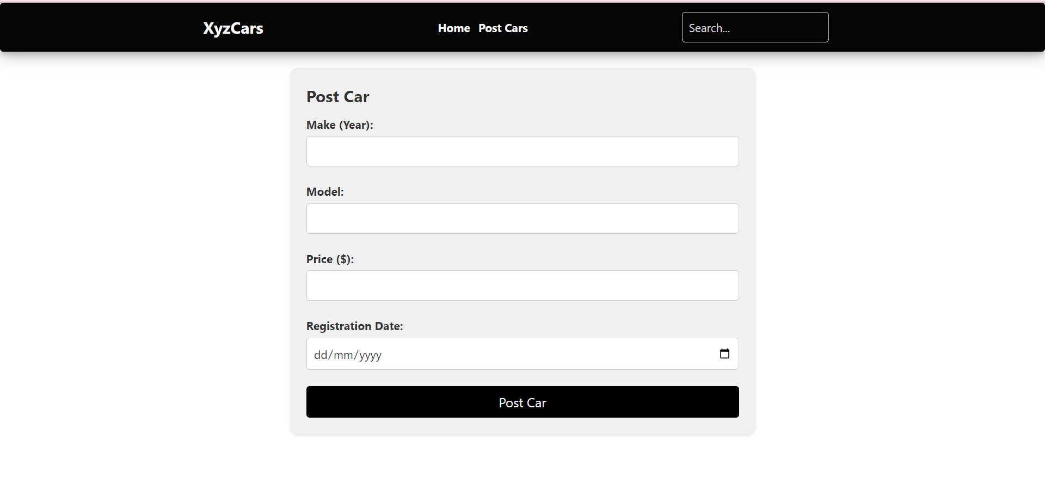
   3. Car Details (GET Method)  
      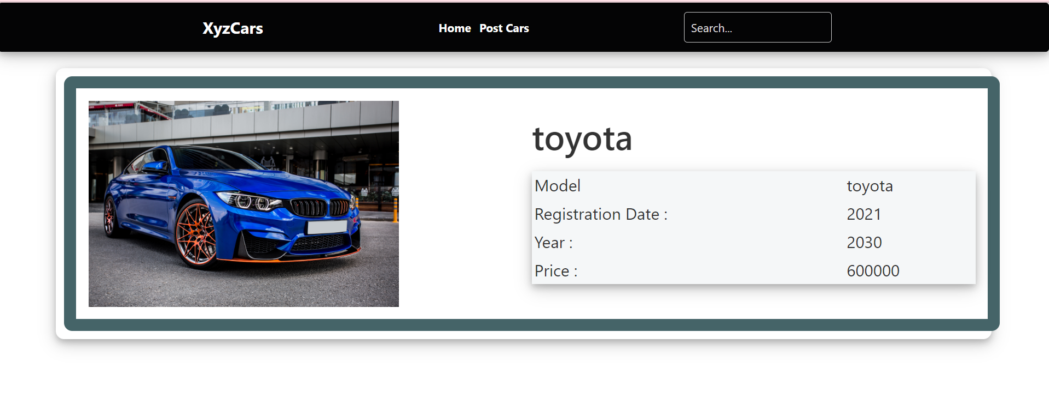

* 1. MySQL Data Before Post  
     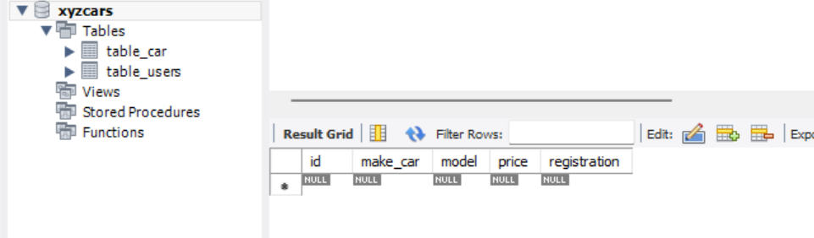
  2. MySQL Data After Post

